NATIONAL FORUM FOR EQUITY AND DEVELOPMENT (NFD)

STATEMENT OF IDEOLOGY

2025
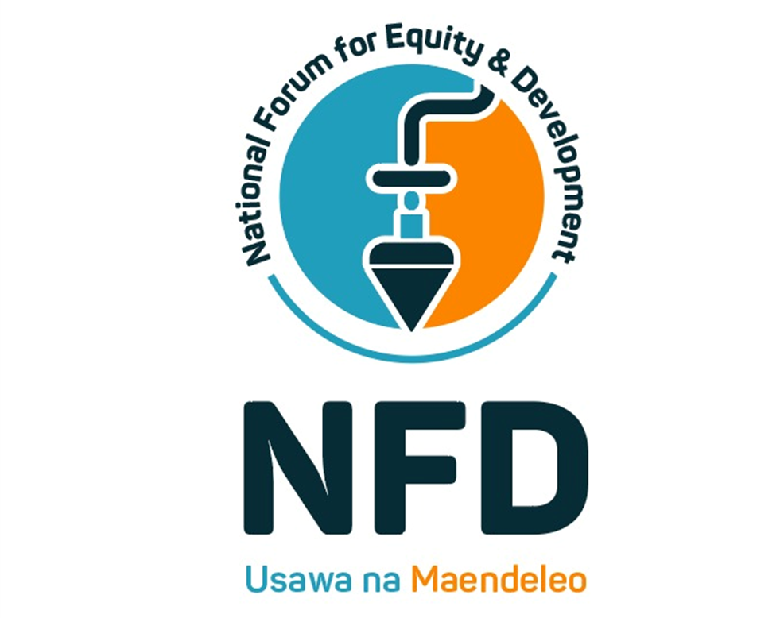

Telephone: 0729330634
P. O Box P. O. Box 13407–00400 Tom Mboya Street, Nairobi
Table of Contents
I. INTRODUCTION 3
II. POLITICAL IDEOLOGY 3
III. GUIDING PRINCIPLES 4
IV. OUR VALUES 5
V. AIMS AND OBJECTIVES 5
Eradicating Inequalities 6
Universal Access to Essential Services 6
Youth and Women Empowerment 6
Environmental Sustainability and Climate Resilience 6
Fostering Unity and National Cohesion 7
Building Ethical, Participatory Institutions 7
Anchoring the Republic in Civic Culture 7
VI. ALIGNMENT WITH THE PARTY MANIFESTO 7
VII. COMMUNICATING OUR IDEOLOGY 11
VIII. IMPLEMENTATION STRATEGIES 13
Timeline of Implementation: 13
IX. PARTY PARTICULARS 13
X. COMPLIANCE WITH THE LAW 14
XI. MONITORING, EVALUATION AND REVIEW FRAMEWORK 14

I. INTRODUCTION
The National Forum for Equity and Development (NFD) was founded to advance the cause of equity, social justice, and sustainable development by addressing long-standing inequalities and empowering communities across Kenya. In alignment with our transformative manifesto, NFD embraces the ideology of Civic Republicanism—a philosophy rooted in citizen empowerment, equitable governance, and inclusive progress.
We believe that the pathway to a better Kenya lies in ensuring that every citizen is both protected and empowered, and that public institutions operate transparently and with integrity, serving not private interests but the common good. At its core, NFD is driven by a deep belief that all Kenyans, regardless of background, should have an active and equal voice in shaping the nation’s future.

II. POLITICAL IDEOLOGY
The National Forum for Equity and Development (NFD) is firmly grounded in the political tradition of Civic Republicanism, an ideology centered on active citizenship, public virtue, equitable governance, and institutional integrity. This philosophy asserts that true freedom is not simply the absence of interference, but the absence of domination – particularly by unaccountable elites, state capture, or systemic exclusion.
In Civic Republicanism, citizens are not passive recipients of services but active participants in the shaping of their collective destiny. It is through deliberate and ongoing civic engagement that public life becomes responsive, just, and inclusive. The republic thrives only when the people are empowered, informed, and capable of holding power to account.
NFD’s ideological foundation insists that:
- Government exists to serve the people, not to benefit the powerful few. State authority must be exercised transparently and accountably, rooted in moral responsibility to the public.
- Citizenship is a daily practice, not a periodic act of voting. Every Kenyan has a duty to engage with governance, question leadership, and contribute to building institutions.
- Institutions must be just and impartial, with clear checks and balances to guard against tyranny, elite capture, or neglect of the common good.
- Liberty without justice is hollow. Equal participation requires that historical and structural disadvantages be addressed through fair policies, affirmative investment, and social protection.
NFD’s version of Civic Republicanism is adapted to Kenya’s unique realities. In a country marked by ethnic polarization, unequal development, and youth marginalization, our approach is intentionally community-led, constitutionally grounded, and morally driven.
We envision a Kenya where:
- The state is proactive, guaranteeing essential services and upholding justice;
- The public realm is open, with every citizen encouraged to influence budgets, laws, and local priorities;
- Public virtue is restored, with ethical leadership modeled at every level;
- Freedom is protected not just by rights on paper but by institutions that work for all.
In the broader political spectrum, NFD stands between the center and center-left, promoting a balanced state that intervenes to secure opportunity, regulate unfair systems, and uphold dignity for all Kenyans. This is not a politics of dependency—but one of shared responsibility between citizens and state to forge a republic that works for everyone.
Our manifesto, structured around nine transformative pillars, operationalizes this ideology by placing power, development, and justice directly into the hands of the people.

III. GUIDING PRINCIPLES
NFD’s work is guided by the following principles:
- Equity – Ensuring that all regions and communities benefit fairly from national resources.
- Inclusion – Prioritizing the voices and needs of marginalized groups, including women, youth, persons with disabilities, and ethnic minorities.
- Accountability – Promoting transparency and ethical governance in all institutions and public service.
- Sustainability – Advancing development strategies that protect the environment and secure the well-being of future generations.
- Unity in Diversity – Celebrating Kenya’s cultural richness while forging a shared sense of national belonging.

IV. OUR VALUES
Our values reflect the spirit of our manifesto and the heartbeat of our ideology:
- Justice – Upholding fairness in law, policy, and governance.
- Solidarity – Building cohesive and caring communities.
- Equality – Expanding access to opportunity for all, regardless of background.
- Development – Driving inclusive and sustainable economic growth for every Kenyan.

V. AIMS AND OBJECTIVES
The aims and objectives of the National Forum for Equity and Development (NFD) are rooted in our unwavering commitment to the republican ideals of equity, civic freedom, public virtue, and the rule of law. These objectives are not abstract aspirations—they are grounded in Kenya’s constitutional mandate and the lived realities of its people. They reflect our belief that the republic must guarantee not only rights, but also the material and institutional conditions necessary for all citizens to enjoy those rights in full.
Each objective is designed to ensure that the republic serves the people—not the privileged few—by dismantling systems of domination and replacing them with structures of justice, accountability, and opportunity.

Eradicating Inequalities
We aim to address deep-seated disparities in health, education, infrastructure, and access to opportunity that have historically disadvantaged certain regions, communities, and social groups. This will be done through deliberate redistribution of public investment, affirmative development policies, and institutional reforms. In a Civic Republican society, inequality is not just a social problem—it is a civic crisis that weakens the moral legitimacy of the state and erodes national unity.

Universal Access to Essential Services
We seek to institutionalize universal and affordable access to public goods such as healthcare, education, water, and social protection. These are not acts of charity or development favors—they are the civic entitlements of every Kenyan. A republic that fails to guarantee essential services is one that abandons its own people. Our policies are therefore designed to operationalize Article 43 of the Constitution, not just in law but in everyday life.

Youth and Women Empowerment
NFD aims to empower youth, women, and marginalized groups as full political, economic, and cultural participants in the republic. In a truly free society, every citizen must have an equal chance to lead, create, and thrive. We will champion legal, institutional, and economic reforms that dismantle systemic exclusion, support leadership training, increase access to capital, and ensure representation at all levels of decision-making.

Environmental Sustainability and Climate Resilience
We are committed to advancing a just ecological transition. Our objective is to protect Kenya’s natural ecosystems, adapt to climate change, and build environmental justice from the ground up. A republic is not only judged by how it treats its people, but how it safeguards its land and resources for future generations. We will lead efforts in agroecology, renewable energy, reforestation, and community-led conservation.

Fostering Unity and National Cohesion
We aim to build a republic where diversity is not a threat but a source of strength. Our objective is to foster cultural pluralism, inter-ethnic dialogue, regional equity, and mutual respect across communities. Civic Republicanism teaches that shared citizenship must transcend tribalism, sectarianism, and patronage. We will support educational, media, and policy efforts that affirm national unity, protect minority rights, and promote patriotism without prejudice.

Building Ethical, Participatory Institutions
We are determined to institutionalize transparency, integrity, and accountability in governance. Our objective is to create public institutions that are citizen-facing, responsive, and resilient to political interference. From the smallest ward office to national parastatals, our goal is to ensure that public officials act as stewards of the republic—not as brokers of privilege.

Anchoring the Republic in Civic Culture
Our final aim is cultural: to cultivate a civic-minded population that views politics as service, not conquest. We seek to promote active citizenship, informed debate, respect for the Constitution, and the civic habits needed to build and sustain a functional republic.

VI. ALIGNMENT WITH THE PARTY MANIFESTO
The manifesto of the National Forum for Equity and Development (NFD) is not merely a political tool – it is a constitutional and moral commitment. It gives life to our Civic Republican ideology by translating timeless republican values into clear, practical policy action.
Civic Republicanism views liberty as self-rule: the capacity of a people to govern themselves justly, free from domination – be it by elites, corporations, foreign interests, or corrupt bureaucracies. Our manifesto reflects this belief by positioning citizens at the center of development, grounding legitimacy in public accountability, and distributing power fairly across communities.
Each of the nine core policy pillars outlined in our manifesto is a concrete expression of Civic Republican values. These pillars collectively reaffirm our belief that freedom, justice, and dignity are achieved not through rhetoric, but through the practice of accountable governance, inclusive development, and citizen participation.
- Civic Participation and Governance Accountability
In a civic republic, public authority must arise from public consent. This pillar prioritizes structural inclusion of citizens in planning, budgeting, legislation, and oversight. From civic forums to digital feedback tools, NFD aims to institutionalize people’s voices into every tier of governance—not as an afterthought, but as a constitutional imperative. This is how we reclaim the state from political elites and restore trust in the public realm.
- Primary Health Care and Community Health Systems
Civic Republicanism insists that health is a public good, and that no citizen can be truly free while living in fear of preventable illness. The manifesto’s commitment to rural health centers, mobile clinics, and trained community health workers ensures that all Kenyans – especially in arid, remote, and informal areas – can live dignified, healthy lives. Public health is not charity; it is justice.
- Early Childhood Development and Vocational Skills
In a republic, the capacity to participate must be cultivated from early life. This pillar responds to the urgent need for accessible, equitable education and job training. By investing in ECDE, harmonizing teacher pay, and expanding youth innovation hubs, NFD ensures that the future of the republic is built by informed, skilled, and confident citizens – especially the marginalized majority of youth and rural learners.
- Local Economic Empowerment through Trade and Enterprise
Economic autonomy is fundamental to republican liberty. When smallholders, artisans, and informal traders lack access to credit, markets, and infrastructure, they are dominated by systems beyond their control. This pillar dismantles those barriers through affirmative policies – zero-interest loans, trade fairs, cooperatives, and public procurement reform – allowing citizens to be self-reliant and locally rooted agents of prosperity.
- Environmental Justice and Climate Resilience
A republic must preserve the land for its people, not for extraction by a few. This pillar promotes sustainable land management, watershed protection, and climate-responsive planning led by local communities. Through reforestation, early warning systems, and community-based adaptation, NFD ensures that environmental stewardship is not outsourced – it is civic duty, locally led, and justice-driven.
- National Cohesion and Cultural Pluralism
A diverse republic requires shared citizenship. This pillar aims to transform ethnicity, language, and culture from fault lines into foundations of unity. Through inter-ethnic dialogue, cultural heritage centers, and equitable media representation, we create a civic identity that honors our differences while committing to a common future. Republicanism requires unity through diversity, not conformity.
- National Security and Community Policing
Security must never be a tool of domination. In a civic republic, law enforcement exists to protect the people, not to oppress them. This pillar redefines security through community ownership, rights-based training, and citizen oversight. We aim to build trust between state and citizen, with inclusive, intelligence-led policing that ensures peace, safety, and civic dignity for all.
- Digital Transformation and E-Governance
In the modern era, exclusion from digital infrastructure is exclusion from the republic itself. This pillar democratizes technology—providing last-mile internet, digitized services, and open government platforms that enable citizens to access entitlements and monitor public performance. By bridging the digital divide, we equip citizens to engage, innovate, and oversee governance in real time.
- Affordable Housing and Urban Equity
Shelter is not a privilege; it is a condition of civic equality. A republic where the majority live in informal settlements cannot claim to be just. This pillar commits to dignified, participatory housing models that combine tenure security, zoning reform, and public-private partnerships—so that urban development is not for the rich alone, but for every Kenyan seeking safety and belonging.

These pillars are not isolated—they are interwoven. Together, they respond to the core problem Civic Republicanism seeks to solve: that domination—by poverty, corruption, exclusion, or inefficiency—erodes freedom and undermines public life.
They also address the Constitution of Kenya’s call to action: to build a nation founded on the values of equity, democracy, human rights, and sustainable development.
In every aspect of the manifesto—from agriculture, education, health, and employment to religion, technology, culture, and industry—our ideology is present. It is evident in our moral tone, in our legal strategy, in our participatory mechanisms, and in our deep respect for the public good.
This is not politics as usual. This is the work of republic-building: patient, principled, people-driven.

VII. COMMUNICATING OUR IDEOLOGY
As a Civic Republican Party, the National Forum for Equity and Development (NFD), ideology must not remain confined to internal documents or campaign rhetoric. It must be communicated broadly, clearly, and consistently—so that citizens are not only informed, but empowered to act. Civic Republicanism emphasizes that an engaged and educated citizenry is the cornerstone of a free and just society. Therefore, the way we communicate our ideas must itself reflect our values: participatory, transparent, accessible, and inclusive.
Our communication strategy is grounded in the belief that every Kenyan—regardless of location, education level, or language—has a right to understand and influence the political decisions that shape their lives. We do not view the public as passive recipients of policy, but as co-authors of Kenya’s future.
To achieve this, NFD will deploy a multi-layered, people-centered approach to ideological communication, including the following strategies:
- Civic Education Campaigns
We will organize structured civic education forums at ward, constituency, and county levels. These forums will go beyond explaining voting procedures; they will unpack the meaning of equity, justice, accountability, and public duty as envisioned in our ideology. By embedding our republican values into regular civic learning, we aim to foster political maturity and deepen public understanding of the republic we seek to build.
- Digital and Print Media Platforms
Recognizing the power of both traditional and modern media, NFD will invest in accessible content in Kiswahili, English, and local languages across newspapers, radio, television, and social media. From explainer videos to illustrated civic guides, we will tailor content to reach all demographics—especially the youth, the rural poor, and historically excluded groups.
- Community-Led Messaging
Our ideology will not be transmitted top-down alone. We will empower community champions – including teachers, religious leaders, youth leaders, elders, and women's groups – to serve as messengers of civic values within their own neighborhoods and social circles. These grassroots custodians will localize the ideology in a way that resonates with lived experience.
- Training of Party Cadres and Aspirants
Every NFD leader, from national to village level, will be required to undergo training in Civic Republican values and their practical applications. This will ensure ideological consistency across all levels of the party and cultivate a culture of leadership rooted in public service and ethical governance.
- Interactive Platforms for Dialogue
We will build mechanisms for two-way engagement – both physical and digital – where citizens can critique, suggest, and challenge our ideological positions. Virtual town halls, surveys, policy hackathons, and feedback portals will be used to capture citizen input and foster continuous dialogue.
- School and Youth Integration
Through partnerships with educational institutions, we aim to support the development of civic education curricula and student-led civic clubs. These will equip the next generation with the tools, language, and critical thinking skills to practice republican citizenship from a young age.
- Visibility of Ideology in Action
Perhaps the most important way to communicate our ideology is by practicing it. Every policy we propose, every leader we nominate, and every partnership we form must reflect our values. We will publish regular progress scorecards and manifest public accountability through action – not just words.

VIII. IMPLEMENTATION STRATEGIES
NFD’s ideology will be put into practice through:
- Policy Reforms – Crafting laws and regulations that embed equity, participation, and integrity in governance.
- Public Engagement – Educating citizens about their rights and roles in shaping public life.
- Strategic Partnerships – Working with civil society, academia, and the private sector to drive development.
- Grassroots Mobilization – Strengthening community structures and leadership.
- Sustainability Programs – Advancing climate adaptation, green energy, and conservation.

Timeline of Implementation:
- Short-Term (0–2 years): Launch civic education, finalize policy drafts, strengthen party presence.
- Medium-Term (2–5 years): Scale partnerships, expand grassroots programs, influence national policy.
- Long-Term (5+ years): Institutionalize reforms, monitor impact, and adapt based on M&E results.

IX. PARTY PARTICULARS
- Symbol: The Plumb Bob (Timazi) – representing equity and balance.
- Slogan: Usawa na Maendeleo (Equity and Development)
- Abbreviation: NFD
- Party Colours: Sky Blue, Gold, White, and Black
Our identity reflects our values. The plumb bob symbolizes fairness and upright governance. Our slogan embodies the belief that true development can only happen when equity is guaranteed for all.

X. COMPLIANCE WITH THE LAW
NFD is fully compliant with the Constitution of Kenya (2010), the Political Parties Act (2011), and related legal frameworks. Our manifesto and ideology are consistent with Articles 10, 91, and 92, which enshrine values of democracy, inclusivity, equity, and sustainable development.

XI. MONITORING, EVALUATION AND REVIEW FRAMEWORK
To ensure that our ideological commitments translate into real outcomes, NFD will establish a robust Monitoring and Evaluation (M&E) Unit. This unit will oversee implementation of policy, track progress through scorecards and annual reports, and ensure transparency through regular public audits.
Every five years, we will conduct a participatory review of both our ideology and manifesto—ensuring continued relevance, responsiveness, and impact in addressing Kenya’s evolving challenges.

